Master Foods Japan

ICS/LADS Data Warehouse (CLIO)

Support & Operation
Table of Contents

1. Modification History 3
2. Environment Overview 4
1. Tier Details 4
2. Batch CLIO versus ICS/LADS Data Warehouse 4
3. Daily Cycle 5
1. Customer Hierachy Data Arrives 5
2. Invoices Arrive 5
3. Daily Hierachy Checker 5
4. Flattening 6
5. Forecast Aggregation 7
6. Invoice Summary Processing 7
7. Business Objects Flag File Creation & Send 8
8. Business Objects Sales Report Processing 8
9. Planning & Management Reports 8
10. Daily Sales Checker 8
4. ICS Settings 11
5. ICS Jobs 16
6. MFJ Website Operation 18
1. Viewing Web Logs 18
2. Modifying ICS Settings 18
3. Re-running Jobs 19
4. Modifying Security/Access 19

Modification History

Date | Version | Description | Reviser
27th July, 2005 | 1.0 | Original (Operation Documentation) | Stephen Gregan
28th July, 2005 | 2.0 | Added Support documentation  Added MFJ Website Operation | Linden Glen
29th July, 2005 | 2.1 | Added Environment Overview | Linden Glen

Environment Overview

Tier Details

Tier | Host | Database | Data/Script Path | Queue Manager
Production | TOKU006 | AP0093P | /ics/lad/prod/ … | TOKU06P1
Test | TOKU006 | AP0080T | /ics/lad/test/ … | TOKU06T1
Development | TOKU006 | AP0087D | /ics/lad/dev/ … | TOKU06D1

Batch CLIO versus ICS/LADS Data Warehouse
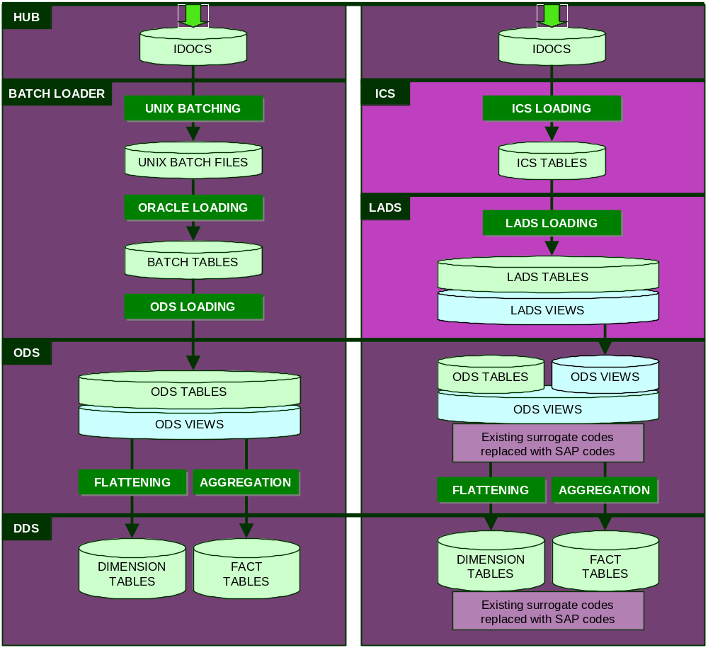

Daily Cycle

Step | Trigger/Timing | Process | Package (DW_APP)
1 | 19:30 – 20:30 | Customer Hierachy Data Arrives | LADS_ATLLAD20
2 | 21:30 – 23:30 | Invoices Arrive | LADS_ATLLAD18
3 | 22:00 | Daily Hierachy Checker | DW_DAILY_HIERACHY_CHECKER
4 | 23:00 | Flattening | DW_FLATTENING
5 | 23:30 | Forecast Aggregation | DW_FORECAST_AGGREGATION
6 | 00:15 – 00:45 | Invoice Summaries Arrive | LADS_ATLLAD12_MONITOR  > DW_RECONCILIATION  > DW_SALES_AGGREGATION
7 | Step 6 Completion | BO Reporting flag file creation & send | DW_FLAG_FILE_CREATION
8 | 01:00 | BO Sales Report Processing | Executed on TOKNTS5
9 | 03:00 | Planning & Management Reports | Executed on TOKNTS9
10 | 03:00 | Daily Sales Checker | DW_DAILY_SALES_CHECKER

Customer Hierachy Data Arrives
The Customer Hierarchy data is sent from Atlas everyday and arrives at LADS during this approximate time frame. The associated interface files contain approximately 30500 individual IDOCs. This information is required for the Data Warehouse Flattening process that is critical for Sales Reporting.

Invoices Arrive
The Invoice data is sent from Atlas on working days and arrives at LADS during this approximate time frame. This information is reconciled to the Invoice Summary data that arrives after midnight.

Daily Hierachy Checker
The Daily Hierarchy Check is a scheduled job that executes at 22:00pm everyday. This job checks that customer hierarchy data has arrived for the current day. An alert is raised and an email sent when this check detects that NO customer hierarchy data was received for today. This function is unable to check that ALL customer hierarchy data has arrived because Atlas does not publish a total count.

Problem Resolution :
- Customer Hierachy Data not received
You will receive an email like :
------------------------------------------------------------------------------------
DW DAILY HIERARCHY CHECKER
==========================
System : LADS
Business Unit : MFJ
Environment : PRODUCTION
Timestamp : 2005/07/27 03:28:49

Procedure : DW_DAILY_HIERARCHY_CHECKER

One or more errors occurred during the Daily Hierarchy Checker execution - refer to web log - DW_DAILY_HIERARCHY_CHECKER - 2005/07/27 15:28:49
------------------------------------------------------------------------------------

  - Refer to the web log specified. An entry will exist similar to :
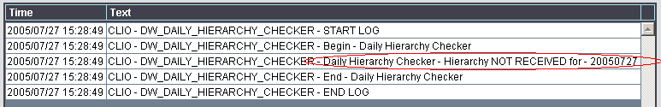

  - Ensure that receiving queue is triggered and has no messages.
- Open a telnet session and connect to TOKU006
- Login as ‘ics’
- Type ‘runmqsc TOKU06P1’
- Type ‘dis q(QL.OUT.ATLLAD20.2)’ – this will display the following :
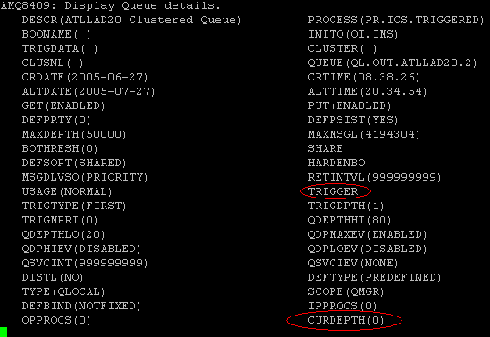
- Note the CURDEPTH (Current Queue Depth) and Trigger status (either TRIGGER or NOTRIGGER)
- If the output is not as above, then further investigation into the TRIGGER failure will need to occur. The details of this are logged in /ics/lad/prod/log/ics_integration.log
- If the output is as above, then continue.
  - Contact the GSM Atlas Outbound Support team to identify if the data has been successfully sent. (**note** the issue could be in either Atlas or the HUB).
NOTE:
If the customer hierarchy data has NOT been fully received before the scheduled 23:00 Flattening job then the Flattening job must be re-run. (See Step 4)

Flattening
The Flattening is a scheduled job that executes at 23:00pm everyday. This job flattens all operational data store reference tables into the dimensional data store dimension tables.

Re-Run Job: Web site option – DW Flattening

Forecast Aggregation
The Forecast Aggregation is a scheduled job that executes at 23:30pm everyday. This job aggregates the operational data store period and month forecast data into the dimensional data store forecast fact tables.

Re-Run Job: Web site option – DW Forecast Aggregation

Invoice Summary Processing
The Invoice Summary data is sent from Atlas working days and arrives at LADS during this approximate time frame. This information is reconciled to the Invoice data that arrived earlier.

The invoice summary monitor (LADS_ATLLAD12_MONITOR) invokes the data warehouse reconciliation procedure (DW_RECONCILIATION) to reconcile the invoice summary data with the invoice data for the same date. If reconciliation is successful then the Sales Aggregation procedure (DW_SALES_AGGREGATION) is automatically triggered. The sales aggregation procedure is triggered for each company (MFJ has two companies 131 and 132).

The data warehouse reconciliation procedure returns the following values:

*OK
The invoice summary reconciles to the invoices. Sales Aggregation is triggered.

*SUM_ONLY
Only the invoice summary data was received. Alert is raised and an email sent.

*TRN_ONLY
Only the invoice data was received. Alert is raised and an email sent.

*VAR_ACCEPT
The invoice summary DOES NOT reconcile to the invoices but is within acceptable range. Sales Aggregation is triggered and an email sent.

*VAR_FATAL
The invoice summary DOES NOT reconcile to the invoices. Alert is raised and an email sent.

Problem Resolution :
- Invoice Summary Imbalance
You will receive an email like :
------------------------------------------------------------------------------------
LADS INVOICE SUMMARY MONITOR
============================

System : LADS
Business Unit : MFJ
Environment : PRODUCTION
Timestamp : 2005/07/22 06:06:16

Procedure : DW_RECONCILIATION

Fatal Variance - Invoice summary does not balance for Date(20050721) Company(131) - Summary(headers=1702,lines=7541,value=172813526) Invoice(headers=600,lines=2861,value=49327600)

- Re-execute DW_RECONCILIATION incase invoices have arrived since callout :
- Connect to AP0093P using SQL Plus
- Execute the following code – substituting the parameters as necessary :
set serveroutput on
declare
var_msg varchar2(4000);
var_msg_rtn varchar2(4000);
begin
var_msg_rtn := dw_reconciliation.reconcile_sales(YYYYMMDD,'131' or '132',var_msg);
dbms_output.put_line('RECONCILIATION RESULT : ' || var_msg_rtn);
end;
- If the RECONCILIATION RESULT is either *OK or *VAR_ACCEPT, then continue.
If the result is not one of these values, then the reason for the invoice summary imbalance will need to be identified, corrected and then continue.
- Re-run Invoice Summary Processing
- Connect to the MFJ ICS Website (http://mfj-lads.ap.mars)
- Under the Configuration menu, select Process Interface
- Filter the view by (ATLLAD12) Atlas to LADS – Invoice Summary
- At the top of the list will be an entry for the most recently received Invoice Summary. Click the blue Interface number in the left column for this interface.
- On the next screen, click Accept. This will initiate the reprocessing of the Invoice Summary, and hence aggregation if reconciliation is successful.
NOTE:
The Planning and Management reports that execute on the MFJ web server (TOKNTS9) will need to be re-run if the reprocessing of the invoice summary and subsequent sales aggregation complete after 03:00am.

Business Objects Flag File Creation & Send
When sales aggregation for BOTH companies has been successfully completed the Flag File Creation procedure (DW_FLAG_FILE_CREATION) for interface ICSBCA01 is executed. This interface (ICSBCA01) sends the flag file to the Business Objects server to trigger the creation of the Sales reports.

Business Objects Sales Report Processing
The Business Objects Sales Reports are scheduled jobs on the MFJ Business Objects Server (TOKNTS5). These reports rely on the Flag File being sent from the data warehouse to trigger their execution.

Planning & Management Reports
The Planning and Management reports are a scheduled job that executes at 03:00am everyday on the MFJ Web Server (TOKNTS9). These reports assume that ALL data warehouse procedures have been completed by this time.

Daily Sales Checker
The Daily Sales Check is a scheduled job that executes at 03:00am everyday. This job checks that invoice summary data has arrived for the previous day for all companies when required. This job ONLY checks for the arrival of the invoice summary, the invoice summary monitor handles the reconciliation of the invoice summary. The DAILY_SALES_CHECKER settings specify on which days of the week invoice summary data is expected to arrive at LADS. An alert is raised and an email sent when this check detects that NO invoice summary data was received for yesterday when required.

Problem Resolution :
- Invoice Summary is NOT received
You will receive an email like :
------------------------------------------------------------------------------------
DW DAILY SALES CHECKER
======================

System : LADS
Business Unit : MFJ
Environment : PRODUCTION
Timestamp : 2005/07/22 03:00:03

Procedure : DW_DAILY_SALES_CHECKER

One or more errors occurred during the Daily Sales Checker execution - refer to web log - DW_DAILY_SALES_CHECKER - 2005/07/22 03:00:02

- Refer to the web log specified. An entry will exist similar to :
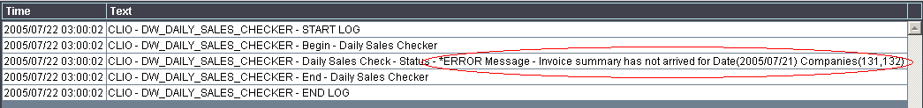

- Ensure that receiving queue is triggered and has no messages.
- Open a telnet session and connect to TOKU006
- Login as ‘ics’
- Type ‘runmqsc TOKU06P1’
- Type ‘dis q(QL.OUT.ATLLAD12.2)’ – this will display the following :
- Note the CURDEPTH (Current Queue Depth) and Trigger status (either TRIGGER or NOTRIGGER)
- If the output is not as above, then further investigation into the TRIGGER failure will need to occur. The details of this are logged in /ics/lad/prod/log/ics_integration.log
- If the output is as above, then continue.
- Contact the GSM Atlas Outbound Support team to identify if the data has been successfully sent. (**note** the issue could be in either Atlas or the HUB).
- Once the invoice summary has been successfully received, the invoice summary will automatically trigger the sales aggregation process and subsequently the sending of the flag file to the BO server for sales reporting.
NOTE:
The Planning and Management reports that execute on the MFJ web server (TOKNTS9) must be re-run as they are scheduled to execute at 03:00am everyday and this problem will not be rectified before the Planning and Management reports have started execution.

ICS Settings

Group: DAILY_SALES_CHECKER

This group setting applies to the DW_DAILY_SALES_CHECK job that is scheduled to execute at 03:00am everyday. The job uses the DW_DAILY_SALES_CHECKER package to check for the arrival of a sales invoice summary for all companies for the previous day. When a sales invoice summary should have been delivered for a particular day and has not arrived by 03:00am an alert will be raised and an email sent. The standard values for this group are Y for Monday to Friday inclusive and N for Saturday and Sunday.

Codes
CHECK_MONDAY
CHECK_TUESDAY
CHECK_WEDNESDAY
CHECK_THURSDAY
CHECK_FRIDAY
CHECK_SATURDAY
CHECK_SUNDAY

Values
Y = yes - a sales invoice summary should have arrived for all companies for that day.
N = no - a sales invoice summary will not be sent for that day.

Group: DW_ALERT

This group setting is used to specify error alert messages for the various processes with the MFJ data warehouse.

Codes
DAILY_HIERACHY_CHECKER
DAILY_SALES_CHECKER
FCST_AGGREGATION
FLAG_FILE_CREATION
GRD_FLATTENING
REGIONAL_DBP
SALES_AGGREGATION
SALES_RECONCILIATION

Values
*NONE = No alert will be raised.
Alert Text = An alert will be raised with this text.

Group: DW_EMAIL_GROUP

This group setting is used to specify error email groups for the various processes with the MFJ data warehouse.

Codes
DAILY_HIERACHY_CHECKER
DAILY_SALES_CHECKER
FCST_AGGREGATION
FLAG_FILE_CREATION
GRD_FLATTENING
REGIONAL_DBP
SALES_AGGREGATION
SALES_RECONCILIATION

Values
*NONE = No email will be sent.
Notes Email Group = An email will be sent to this group.

Group: DW_JOB_GROUP

This group setting is used to specify job groups for the various triggered processes with the MFJ data warehouse. The job group determines which group of background daemon processors select the procedure for execution.

Codes
FLAG_FILE_CREATION
SALES_AGGREGATION

Values
Job Group Value

Group: DW_SALES_TRAN_COUNT_VARIANCE

This group setting is used to an acceptable transaction count variance between the invoice summary and related invoices. The variance can be specified for each company. The sales aggregation processes will trigger when the transaction count variance is within this acceptable range and an email will be sent. The sales aggregation processes will NOT trigger when the transaction count variance is outside this acceptable range and an alert will be raised and an email will be sent. This setting works in tandem with the DW_SALES_TRAN_VALUE_VARIANCE setting.

Codes
131
132

Values
0 = No variance allowed.
Number = An acceptable transaction count variance for sales aggregation to continue.

Group: DW_SALES_TRAN_VALUE_VARIANCE

This group setting is used to an acceptable transaction value variance between the invoice summary and related invoices. The variance can be specified for each company. The sales aggregation processes will trigger when the transaction value variance is within this acceptable range and an email will be sent. The sales aggregation processes will NOT trigger when the transaction value variance is outside this acceptable range and an alert will be raised and an email will be sent. This setting works in tandem with the DW_SALES_TRAN_COUNT_VARIANCE setting.

Codes
131
132

Values
0 = No variance allowed.
Number = An acceptable transaction value variance for sales aggregation to continue.

Group: LADS_IDOC_ACK

This group setting is used to send an IDOC acknowledgement to Atlas for each specific type of IDOC.

Codes
ATLDWJ14
ATLLAD01
ATLLAD02
ATLLAD03
ATLLAD04
ATLLAD05
ATLLAD06
ATLLAD07
ATLLAD08
ATLLAD09
ATLLAD10
ATLLAD11
ATLLAD12
ATLLAD13
ATLLAD14
ATLLAD15
ATLLAD16
ATLLAD17
ATLLAD18
ATLLAD19
ATLLAD20
ATLLAD21
ATLLAD22
ATLLAD23

Values
Y = yes – send IDOC acknowledgement.
N = no – do NOT send an IDOC acknowledgement.

Group: LADS_MONITOR_EMAIL_GROUP

This group setting is used to specify error email groups for the various LADS interfaces.

Codes
ATLDWJ14
ATLLAD01
ATLLAD02
ATLLAD03
ATLLAD04
ATLLAD05
ATLLAD06
ATLLAD07
ATLLAD08
ATLLAD09
ATLLAD10
ATLLAD11
ATLLAD12
ATLLAD13
ATLLAD14
ATLLAD15
ATLLAD16
ATLLAD17
ATLLAD18
ATLLAD19
ATLLAD20
ATLLAD21
ATLLAD22
ATLLAD23

Values
*NONE = No email will be sent.
Notes Email Group = An email will be sent to this group.

Group: LADS_PURGING

This group setting is used to specify the number of days history to be kept for the various LADS transactional interfaces.

Codes
ATLDWJ14
ATLLAD01
ATLLAD02
ATLLAD03
ATLLAD09
ATLLAD12
ATLLAD13
ATLLAD14
ATLLAD16
ATLLAD18
ATLLAD20

Values
Number = The number of days history to be kept.

Group: TRIGGER_SUBMIT_ALERT

This group setting is used to specify error alert messages for processes that are triggered by the LICS_TRIGGER_SUBMITTER package. These processes are typically triggered from the ICS web site.

Codes
FCST_AGGREGATION
FPPS_EXTRACT

Values
*NONE = No alert will be raised.
Alert Text = An alert will be raised with this text.

Group: TRIGGER_SUBMIT_EMAIL_GROUP

This group setting is used to specify error email groups for processes that are triggered by the LICS_TRIGGER_SUBMITTER package. These processes are typically triggered from the ICS web site.

Codes
FCST_AGGREGATION
FPPS_EXTRACT

Values
*NONE = No email will be sent.
Notes Email Group = An email will be sent to this group.

Group: TRIGGER_SUBMIT_JOB_GROUP

This group setting is used to specify job groups for processes that are triggered by the LICS_TRIGGER_SUBMITTER package. These processes are typically triggered from the ICS web site. The job group determines which group of background daemon processors select the procedure for execution.

Codes
FCST_AGGREGATION
FPPS_EXTRACT

Values
Job Group Value.

ICS Jobs

Job: DW_DAILY_HIERARCHY_CHECK

This job is scheduled to execute at 22:00pm everyday. The job uses the DW_DAILY_HIERARCHY_CHECKER package to check for the arrival of customer hierarchy data for the current day. When customer hierarchy data has not arrived by 22:00pm an alert will be raised and an email sent.

Job: DW_DAILY_SALES_CHECK

This job is scheduled to execute at 03:00am everyday. The job uses the DW_DAILY_SALES_CHECKER package to check for the arrival of a sales invoice summary for all companies for the previous day. When a sales invoice summary should have been delivered for a particular day and has not arrived by 03:00am an alert will be raised and an email sent.

Job: DW_FCST_AGGREGATION

This job is scheduled to execute at 23:30pm everyday. The job uses the DW_DAILY_FORECAST_AGGREGATION package to aggregate the operational data store period and monthly forecast data into the dimension data store fact tables. The forecast aggregation can also be exeuted from the web site by an authorised user from the Planning Department.

Job: DW_FLATTENING

This job is scheduled to execute at 23:00pm everyday. The job uses the DW_FLATTENING package to flatten the operational data store master data into the dimension data store dimension tables.

Job: DW_PROCESS01 and DW_PROCESS02

These jobs are background daemon processors that are used to process any data warehouse triggered procedures that specify DWP as their job group (eg. sales aggregation, etc).

Job: INBOUND_CUST_HIER

This job is a background inbound interface processor that is used to process the Customer Hierarchy interface (ATLLAD20). The Customer Hierarchy interface must be processed in serial as an artificial primary key is generated because none is supplied by Atlas.

Job: INBOUND_REF#01 - INBOUND_REF#02 - INBOUND_REF#03 - INBOUND_REF#04

These jobs are background inbound interface processors used to process all reference interfaces except the Customer Hierarchy interface.

Job: INBOUND_TRN#01 - INBOUND_TRN#02 - INBOUND_TRN#03 - INBOUND_TRN#04

These jobs are background inbound interface processors used to process all transaction interfaces.

Job: LADS_PURGING

This job is scheduled to execute at 07:00am everyday. The job uses the LADS_PURGING package to remove historical LADS transactional data beyond the current purge settings.

Job: LICS_PURGING

This job is scheduled to execute at 07:00am everyday. The job uses the LICS_PURGING package to remove historical LICS data beyond the current purge settings.

Job: OUTBOUND_PRC01

This job ia a background outbound interface processor used to process all outbound interfaces.

Job: REGDBP01_TUE – WED – THU – FRI - SUN

These jobs are scheduled to execute at 05:00am on the specified days. The job uses the DW_REGIONAL_DBP package to create the REGDBP01 outbound interface.

Job: REGDBP02_TUE – WED – THU – FRI - SUN

These jobs are scheduled to execute at 05:00am on the specified days. The job uses the DW_REGIONAL_DBP2 package to create the REGDBP02 outbound interface.

MFJ Website Operation

Viewing Web Logs
- Connect to the MFJ Website (http://mfj-lads.ap.mars)
- From the Monitoring menu, select Log Monitoring
- The Log Monitor initially displays all logs in order of most recent
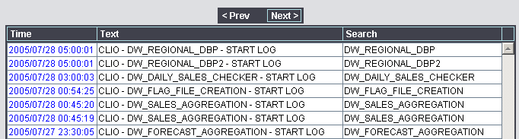
- Using the search option can refine the result set. In the Log Search field, enter the Log Type as seen in the ‘Search’ column that you wish to see, and also a date/time if required.
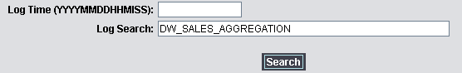
- Clicking on the date/time column for a record will display the complete log details in a new window
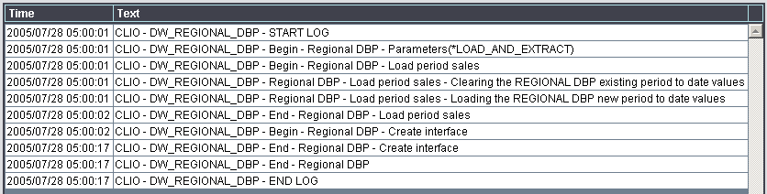

Modifying ICS Settings
- Connect to the MFJ Website (http://mfj-lads.ap.mars)
- From the Configuration menu, select Setting Configuration
- Click the blue ‘Update’ text next to the record you wish to modify.
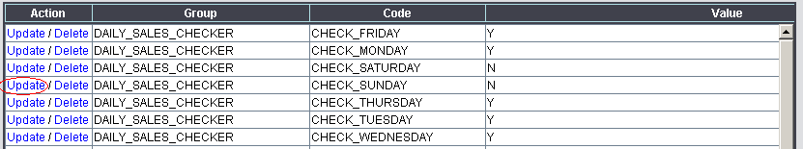
- This will display the edit page for that record.
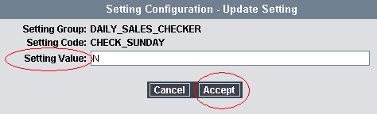
- Make the setting change as necessary, and click Accept to commit the changes.

Re-running Jobs
- Connect to the MFJ Website (http://mfj-lads.ap.mars)
- From the MFJ Local Functions menu, select the process you wish to run
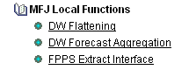
- The next screen will be as below – click Submit to execute the process
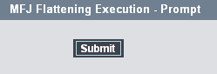
- Once submitted, you will be taken to a screen confirming the submission :
”MFJ Flattening successfully submitted”
- Navigate to the Web Logs to find the latest entry for the process just submitted to check for errors/success/execution status.
- NOTE: This should only be run as required (e.g. re-running flattening during the day could potentially effect users executing reporting at that point in time).

Modifying Security/Access
- Map the network drive : \\10.148.4.24\data (connect as APDOM\TOKADMIN)
- Browse to \data\Inetpub\wwwroot\MFJ_LAD
- Edit security/menu files as required

